2nd Annual Larry Hoaldridge Memorial Event

“Living the Legacy” – SWR 1st Choice Events

April 9-10 – Hosted by Cowtown Vettes (CTV)

OFFICIAL EVENT FLYER
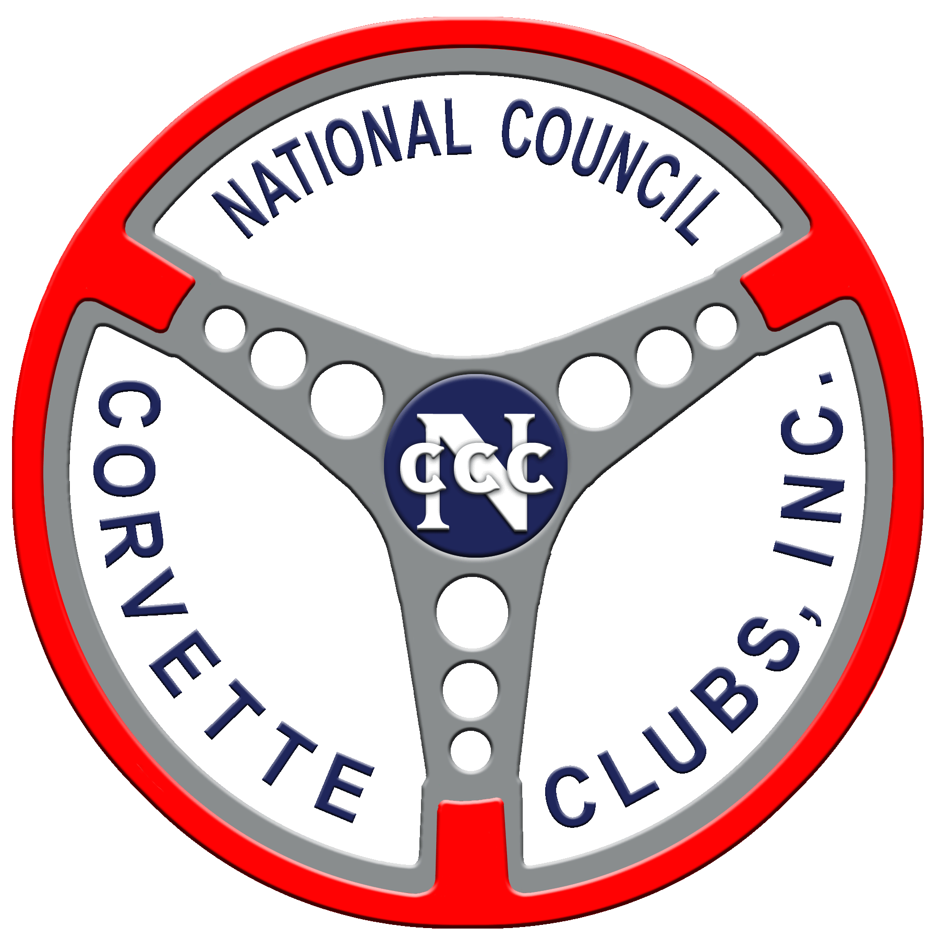
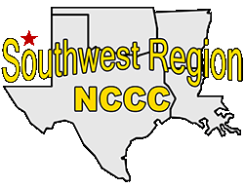
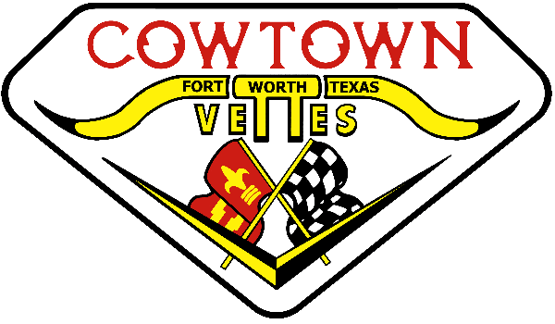
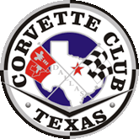
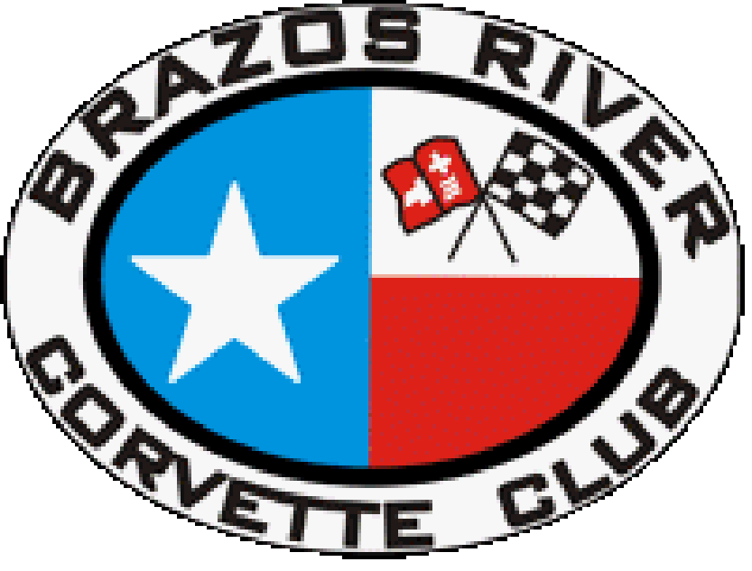
Join Cowtown Vettes (CTV) for the 2nd Annual Larry Hoaldridge Memorial Event, consisting of fourteen low-speed autocrosses. We will host seven autocross events (CTV Sanctions) on Saturday and seven autocross events (CTV, CCT & BRCC Sanctions) on Sunday. The autocross events will be held at Burleson High School in Burleson, TX. Lunch meal tickets will be provided both days, with your full registration package. A “Living the Legacy” hospitality will be Saturday evening from 6pm to 9pm and FTD awards will be presented at the host hotel (Hampton Inn - 13251 Jake Ct, Burleson, TX 76028).

EVENT INFORMATION PAGE: (and Online Registration)
Lodging: We have rooms blocked at the Hampton Inn 13251 Jake Ct, Burleson, TX 76028. Call the hotel at (817) 295-2727 and notify them that you are with the Cowtown Vettes Autocross for the special rate of $102.00 per night. The Cut-Off date for the block of rooms (20) at the Hotel is March 17th.
Entrant check-in and tech: will begin on Saturday & Sunday at 7:30 AM, at the track. There will be no class changes after cars are teched unless the car breaks and the break is verified by tech.
Autocross: We will have a fun but technical clean course setup for your enjoyment. Registration ends when the driver’s meeting starts; with the first car out immediately following the parade lap.

Early-Registration Package Entry must be postmarked by Friday April 1st.
There will be Trophies for group FTD. Rigs & Cars may not be left at the track either night.
Event Coordinator: Larry Schaapveld Co-Chair: James Little Governor: Norman Walker (CTV)
Date: April 9, 2022 Type of Event: Low Speed Autocross
Club: Cowtown Vettes (CTV)
Registration Opens: Immediately Location: Burleson High School
Closes: April 9, 2022 – start of Driver’s Mtg. 100 Elk Drive
First Car Out: Following Drivers Meeting & Parade Laps Burleson, TX 76028
Drivers Meeting: 8:30 a.m. Saturday Sanctions: SW-055-001 thru 007

Event Coordinator: Larry Schaapveld Co-Chair: James Little Governor: Norman Walker (CTV)
Date: April 10, 2022 Type of Event: Low Speed Autocross
Club: Cowtown Vettes (CTV)
Registration Opens: Immediately Location: Burleson High School
Closes: April 10, 2022 – start of Driver’s Mtg. 100 Elk Drive
First Car Out: Following Drivers Meeting & Parade Laps Burleson, TX 76028
Drivers Meeting: 8:30 a.m. Saturday Sanctions: SW-055-008 thru 010
Event Coordinator: Larry Schaapveld Co-Chair: James Little Governor: Paul Wolter (CCT) or RCD
Date: April 10, 2022 Type of Event: Low Speed Autocross
Club: Corvette Club of Texas (CCT)
Registration Opens: Immediately Location: Burleson High School
Closes: April 10, 2022 – start of Driver’s Mtg. 100 Elk Drive
First Car Out: Following Drivers Meeting & Parade Laps Burleson, TX 76028
Drivers Meeting: 8:30 a.m. Sunday Sanctions: SW-074-001 thru 002
Event Coordinator: Larry Schaapveld Co-Chair: James Little Governor: Robert Williams (BRCC) or RCD
Date: April 10, 2022 Type of Event: Low Speed Autocross
Club: Brazos River Corvette Club
Registration Opens: Immediately Location: Burleson High School
Closes: April 10 – start of Driver’s Mtg. 100 Elk Drive
First Car Out: Following Drivers Meeting & Parade Laps Burleson, TX 76028
Drivers Meeting: 8:30 a.m. Sunday Sanctions: SW-540-001 thru 002

2nd Annual Larry Hoaldridge Memorial Event

“Living the Legacy” – SWR 1st Choice Events

April 9-10 – Hosted by Cowtown Vettes (CTV)

OFFICIAL EVENT FLYER
BURNOUTS ARE PROHIBITED!
MUFFLERS ARE REQUIRED!
.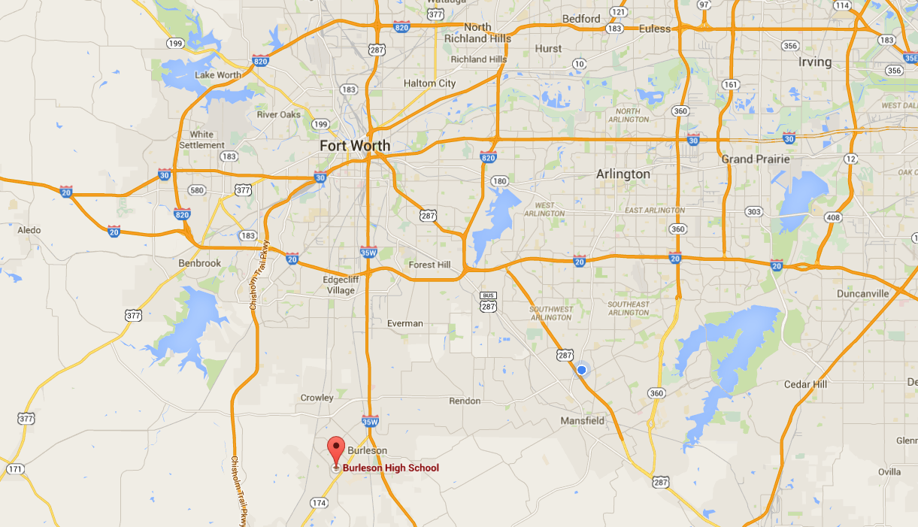
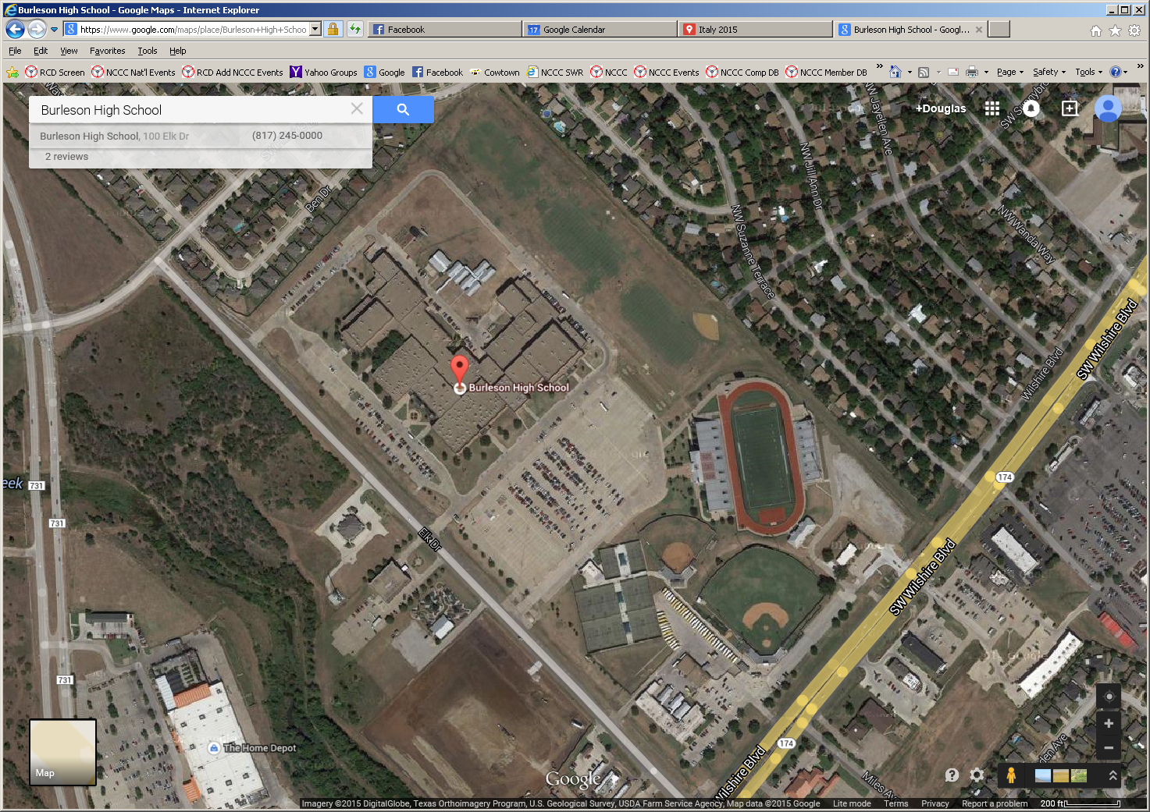
NOTE: If you are not a member of NCCC, NCCC Enthusiast Memberships are available for $35
AUTOCROSS
AREA
RIG, WORKER & SPECTATOR
AREA

2nd Annual Larry Hoaldridge Memorial Event

“Living the Legacy” – SWR 1st Choice Events

April 9-10 – Hosted by Cowtown Vettes (CTV)

OFFICIAL EVENT FLYER
Driver #1 (Please print or type) PERMANENT CAR #:
Name: Email Address:
Address:
City: State: Zip:
Home Phone #: Cell / Work #:
Club Name: NCCC #:
Driver #2 (Please print or type) PERMANENT CAR #:
Name: Email Address:
Address:
City: State: Zip:
Home Phone #: Cell / Work #:
Club Name: NCCC #:
Event | Driver #1 |  |  | Driver #2  Class | Qty | Fees
Event | Year | Group | Class | Driver #2  Class | Qty | Amount | Total
LS1 – SW-055-001 - Sat |  |  |  |  |  | $15
LS2 – SW-055-002 - Sat |  |  |  |  |  | $15
LS3 – SW-055-003 - Sat |  |  |  |  |  | $15
LS4 – SW-055-004 - Sat |  |  |  |  |  | $15
LS5 – SW-055-005 - Sat |  |  |  |  |  | $15
LS6 – SW-055-006 - Sat |  |  |  |  |  | $15
LS7 – SW-055-007 - Sat |  |  |  |  |  | $15
LS8 – SW-055-008 - Sun |  |  |  |  |  | $15
LS9 – SW-055-009 - Sun |  |  |  |  |  | $15
LS10 – SW-055-010 - Sun |  |  |  |  |  | $15
LS11 – SW-074-001 - Sun |  |  |  |  |  | $15
LS12 – SW-074-002 - Sun |  |  |  |  |  | $15
LS13 – SW-540-001 - Sun |  |  |  |  |  | $15
LS14 – SW-540-002 - Sun |  |  |  |  |  | $15
EARLY-REGISTRATION FULL PACKAGE (postmarked on or before April 1, 2022) |  |  |  |  |  | $160
LATE REGISTRATION FULL PACKAGE (postmarked after April 1, 2022) |  |  |  |  |  | $190
7 EVENT – SINGLE DAY REGISTRATION (Specify Events Above) |  |  |  |  |  | $95
Additional Lunches |  |  |  |  |  | $9 ea

Mail Completed Form and check to:

Cowtown Vettes – C/O Kim Little 1911 Spotted Fawn Drive - Arlington, TX 76005 PH: 817-233-9752
Waiver: The following is a RELEASE. It releases the National Council of Corvette Clubs, Cowtown Vettes, its sponsors, and any other persons connected with these events of ALL RESPONSIBILITY whatsoever. NOTES: 1. All entrants MUST completely and truthfully fill out the registration form. All entrants 18 years and older MUST also sign the RELEASE AND WAIVER OF LIABILITY, ASSUMPTION OF RISK AND INDEMNITY AGREEMENT and any other release documents which may be required by NCCC. Entrants younger than 18 years old must have a parent or legal guardian present and submit a properly completed PARENTAL CONSENT, RELEASE AND WAIVER OF LIABILITY, ASSUMPTION OF RISK, AND INDEMNITY AGREEMENT and a MINOR’S ASSUMPTION OF RISK ACKNOWLEDGEMENT and any other release documents, which may be required by NCCC. 2. All drivers MUST be properly licensed per Section 1.7.1, Eligibility to Compete, of the NCCC Rulebook. NOTE: Non-NCCC member participants and workers are not covered by NCCC insurance!
Signature (Driver #1): Date:
Signature (Driver #2): Date:
Contact in Case of Emergency: Name: Phone #:

EARLY PACKAGE EVENT REGISTRATION Deadline is Friday April 1, 2022 (postmarked)
Make Checks Payable to: COWTOWN VETTES TOTAL FEES: $ $___________________

